Chapter 1
Compilation system
- Preprocessing
- Compilation
- Assembly
- linking
Why we should learn about compilation systems
- To optimize performance
- To resolve link-time errors
- To plug security holes
Hardware organization
- Buses - carry bytes of information between components. Chunks of bytes are called words
- I/O devices - input and output. I.e. keyboard and mouse for input, display for output, disk drive for long term storage for data/programs
- Main memory - temporary storage device that holds program/data while CPU executes program. Memory is an array of bytes. Main memory is a bunch of Dynamic Random Access Memory chips.
- Processor - AKA CPU. interprets/executes instructions. Has a register called the program counter, which points at machine language instruction. Repeatedly reads the instruction from the program counter, carries it out, then updates the pc to point at the next instruction. ALU (Arithmetic/Logic Unit) does computation. Here are some tasks it could do:
  - Load - copy word into main register, overwriting what was alr there
  - Store - copy word from register into main memory
  - Update - copies data from 2 registers into ALU
  - I/O read - copies info from I/O into register
  - I/O write - writes register data into I/O
  - Jump - put information into PC
Caches
- Smaller storage drives that temporarily store information that the processor will likely need in the near future
- Physical laws - large storage devices are slower - creates gap between processor & memory which is widening as semiconductor tech improves
- Cache Hierarchy
  - L0: Registers
  - L1: SRAM
  - L2: SRAM
  - L3: SRAM
  - L4: DRAM
  - L5: local disks
  - L6: remote secondary storage (web servers, distributed file systems)
Operating system
- Layer of software for the user to interface w/ the hardware
- Process - the OS’s abstraction for running a program
  - Processes can be concurrent - instructions of one process are interleaved w/ another
  - Called “context switching”
  - Can have multiple threads
- Virtual memory
  - Provides each process w/ the illusion that it is exclusively using main memory
  - Each process has the same view of virtual memory - called the virtual address space
  - Has a few areas - here they are from the lowest up:
    - Program code & data
    - Heap
    - Shared libraries
    - Stack
    - Kernel
Networks

Chapter 2: Representing and Manipulating Information
Virtual address space - set of all possible addresses
big/little endian - how computer architectures organize their bytes
- Little endian - least significant byte comes first
- Big endian - most significant byte comes first
  - Byte ordering is different between architectures
  - Invisible to the user and usually does not matter
  - Can have issues on networks - code written for networks has to standardize byte ordering - sending machine converts to network standard and receiving machine converts to internal representation
  - Casting lets us reference an object according to a different data type, where we can see the byte orderings in C. Usually avoid, but can be useful in systems programming
Boolean algebra - mathematics of true/false
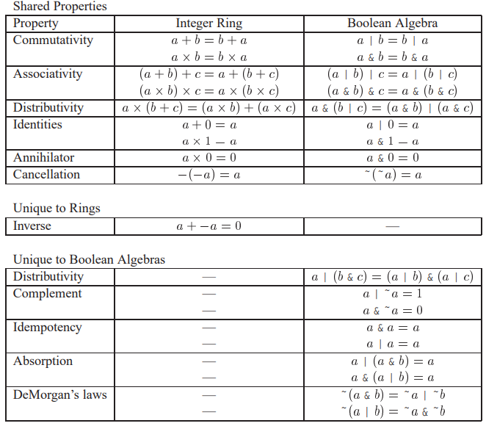
Bitwise operations in c
- | or, & and, ~ not, ^ xor

Integral data types
Integer data type of w bits can be stored as a vector [x_{w-1}…x₀]
- Twos complement form - most significant bit determines if it is positive or negative (1 = negative). If it is negative - then you invert the rest of the bits to determine the number value. Also add 1 to avoid overflow.
  - Max unsigned value is nearly double the max two’s complement form value
  - C does not require two’s complement, but nearly every machine does.
  - Example: -45 in binary. 45 in binary = 00101101, flip it to be 11010010, then add 1 so it is 11010011
- For w bits - unsigned integers can represent {0, 2^{n} - 1} signed integers can represent {-2^{n-1}, 2^{n-1} - 1}
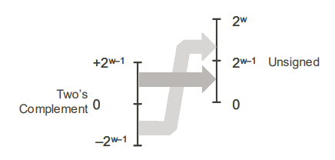
- To expand bit representation i.e. convert to a larger integer
  - Unsigned - add zeroes to the front
  - Signed - add copies of the most significant bit
- Ways to represent signed integers
  - Two’s complement
  - One’s complement
  - Sign Magnitude
- When converting from unsigned to signed (and vice versa) in C, the numeric value may change but the bit pattern does not.

Chapter 3 - Machine Level Representation of Programs

Chapter 4 - Processor Architecture

Chapter 5 - Optimizing Program Performance
5.1 Capabilities and Limitations of Optimizing Compilers
- Memory Aliasing - when multiple pointers point to the same address
  - Can limit the compiler’s ability to optimize.
  - EX:
*xp += *yp;
*xp += *yp;
Cannot be optimized to *xp += 2 * *yp
Because if xp = yp, then the code will quadruple *xp, while the optimized code would only triple xp
- Optimization blocker - aspect of code that prevents the compiler from optimizing
  - Another example of an optimization blocker:
return f() + f() + f() + f();
Cannot be optimized to
return 4 * f();
Because f() might change state
5.2 Expressing Programming Performance
- Cycles per element - number of cycles needed to process an element in a loop
5.7 Understanding Modern Processors

5.11 Some Limiting Factors
- Register spilling - if parallelism exceeds # of available registers then the compiler will store temporary values in memory on the stack
- Branch Misprediction
5.13 Performance Improvement Techniques
- Basic Coding Principles
  - Eliminate excessive function calls. Move computations out of loops if possible
  - Eliminate unnecessary memory references. Use temporary variables to store intermediate results
- Low level optimization
  - Loop unrolling
  - Multiple accumulators and reassociation to improve parallelism
  - Rewrite conditional operations in a functional style to enable compilation via conditional data transfers.

Chapter 6 - Memory Hierarchy

